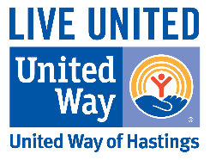

Helping Kids Succeed Handbook Order Form

Cost:
Free (pick up at office) Donations are accepted
$5.00 (handbook will be mailed)

Name:
Address:
City: State: Zip:
Phone: Email:

Drop off or mail completed form and check to:
United Way of Hastings
113 2nd St E, Ste 102
PO Box 353
Hastings, MN 55033
651-438-3337
www.unitedwayofhastings.org

