113 2nd St E, #102
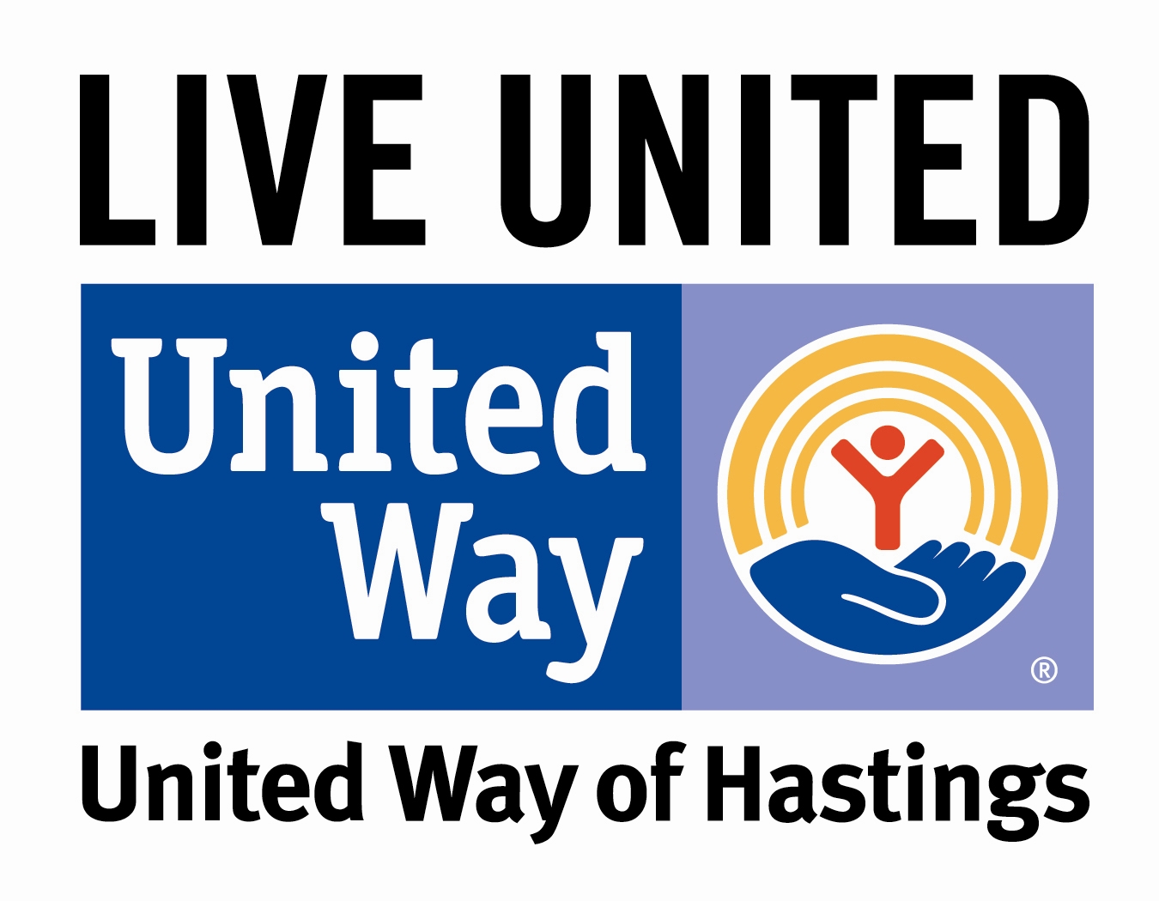PO Box 353
Hastings, MN 55033
(651) 438-3337
www.unitedwayofhastings.org
2021 Allocation Application: Part 2
Application Deadline: February 5, 2021
Required: 1 electronic copy of this completed form
Required to: Mari@unitedwayofhastings.org

Partner Agency Agreement

The United Way of Hastings (UWH) and its Partner Agencies share a vital community commitment to addressing health and human service needs. By joining together as partners in a voluntary, community-wide effort, we mobilize our resources to deliver efficient human service programming related to current needs.

The UWH conducts a fundraising campaign each fall that provides financial support for a health and human service delivery system that is responsive to the needs of the community. This UWH campaign enables the community (both individual and corporate donors) the opportunity to make one pledge of support to help meet the critical health and human care needs of our area. The funds raised are invested in health and human care programs provided by UWH and its Partner Agencies.

UWH agrees to:
- Build partnerships to improve the lives of people in our community. This is accomplished by working to advance the common good in the impact areas of Education, Health, and Financial Stability (basic needs) with a focus on Youth. These are the building blocks for a good life – a quality education that leads to a stable job, enough income to support a family through retirement, and good health.
- Collaborate to identify critical health and human service issues for community action. Periodically determine the needs of the community through survey methods not already addressed by other organizations.
- Convene diverse stakeholders to mobilize the community toward making changes in community conditions.
- Facilitate and participate in initiatives that enhance our collective ability to address changing and emerging community issues.
- Raise awareness of UWH Partner Agencies and build the public’s understanding of the valuable services and results achieved.
- Conduct an annual community-wide campaign to raise resources to address identified community priorities and to build on community strengths. The campaign will have its greatest emphasis between Labor Day and Thanksgiving.
- Maintain ongoing communication with Partner Agencies and inform them of significant changes.
- Conduct fundraising efforts and invest in effective programs and initiatives aimed at impacting human service needs in its service area.
- Distribute approved grants to UWH Agency Partners in the impact areas of Education, Health and Financial Stability (basic needs) with a focus on Youth. The grant amount is based on the UWH’s ability to pay and could change because it is subject to the dollars raised, actual receipt of pledges, community priorities, and unanticipated circumstances. Partner Agencies are not guaranteed to receive any specific allocation or amount from UWH.
- Promote volunteerism and the importance of the system of voluntary nonprofit services and how those increase the quality of life in our community.

Partner Agency agrees to:
- Show support for and partnership with UWH by participating in community events and promotions such as KDWA In Depth, parades, fundraising events, presentations at local businesses, etc.
- Welcome UWH staff, Board Members, Community Investment Committee Members, and other UWH volunteers if they request to tour the agency.
- Collaborate and share needs assessment results with UWH.
- Display “United Way of Hastings Funded Partner Agency” sign at agency and agency events.
- Place “United Way of Hastings Funded Partner Agency” logo on agency print materials, website, and electronic communications including social media. Periodically acknowledge UWH funding via social media. Publicly acknowledge UWH funding in verbal presentations and print/electronic communications. It is important for the community to see the impact of their contributions to the UWH Funded Partner Agencies.
- Hold a UWH led Helping Kids Succeed presentation for agency Board members and staff.
- Grant UWH permission to use the information contained in the agency allocation application materials for media releases, promotional materials, campaign brochures, electronic communications, and UWH website.
- Conduct an annual United Way campaign each fall among its employees and Board members, encourage the participation of its constituency and members in such activities, with a focus on meeting overall community needs.
- Refrain from initiating or participating in any non-UWH organized solicitation of employees at the workplace at any time of the year in service area. An organized solicitation is a federated campaign in the workplace, organized with the support of the employer, through which monetary contributions are solicited from employees.
- Use funds as explicitly described in the Allocation Application and inform UWH of any changes in program criteria or operations that would influence how UWH funds are used. Any funds allocated to the agency that may no longer be used for their program intended purposes will be returned to UWH.
- Cooperate with other agencies and the UWH preventing duplication of efforts and refer clients between agencies, as appropriate.
- Not conduct any direct fundraising during the period of September 1 through October 31. Fundraising limitations include, but are not limited to, large fundraising campaigns and large promotional events. Fundraising limitations do not include small events such as bake sales, food drives, wreath sales, etc. This time frame is the busiest time for the UWH annual pledge drive and UWH appreciates your ongoing cooperation and assistance during this time to help us insure a successful pledge drive.
- Provide a mid-year status report by July 1 and an end-of-year status report by December 31. The report will follow the template provided and will include a description of the impact of the funded program and at least one photo of individuals impacted by the program. Photos may be used by UWH in promotional materials so please obtain appropriate permissions.
- Be familiar with this agreement and communicate the agreement to its Board of Directors, employees, volunteers, and community supporters. By abiding by this agreement, UWH believes that together we can most effectively meet community needs and strengthen the community we serve.

Partner Agency certifies that:
(Combined Federal/State of Minnesota Combined Charities Campaign)
I certify that:
- This agency prepares and makes available to the public an annual report that includes a full description of the organization’s activities and supporting services and identifies its directors/governing body and chief administrative personnel.
- This agency is directed by an active and responsible governing body whose members have no material conflict of interest and a majority of which serve without compensation.
- This agency accounts for its funds in accordance with generally accepted accounting principles, submits IRS 990 form and/or was audited in accordance with generally accepted auditing principles by an independent certified public accountant in the past year.
- The fund raising and administrative expenses are _____ percent of the total support and revenue. I further certify that these expenses are reasonable under all circumstances.
- This agency is a human health and welfare organization, which provides services, benefits or assistance to or conducts activities affecting human health and welfare.
- This agency is organized under the laws of the State of Minnesota.
- This agency is a governmental agency or an agency which is recognized by the Internal Revenue Service as tax exempt under 26 U.S.C. 501 (c) (3) and to which contributions are tax deductible pursuant to 16 U.S.C. 170.
- Any lobbying activities of the agency to influence voting or legislation at the local, state or federal level would classify it as a tax-exempt agency under 26 U.S.C.501 (h).
- This agency’s fund raising practices protect against unauthorized use of its CFC contributor listing: permit no general telephone solicitations of the public, permit no payment of commissions, finders fees, percentages, bonuses or similar practices in connection with its fundraising.
- The publicity and promotional activities of the agency are based upon its actual program and operations. I further certify that they are truthful and non-deceptive, include all material facts and make no exaggerated or misleading claims.
- Funds contributed by Federal personnel are effectively used for the announced purpose of the agency.
- This agency files an IRS 990 (excluding governmental agencies).
- This agency received at least 50 percent of its total support and revenues from sources other than the Federal government or at least 20 percent of its total support and revenue from voluntary contributions from the general public.
- This agency is properly registered with the Minnesota Attorney General to solicit contributions in the State of Minnesota.
- This agency meets all provisions of M.S. Chapter 309 – Minnesota’s Charitable Solicitation Law. (A copy of this Statute is available by contacting the Attorney General’s Office, Charities Division: (651) 296-9412 or (651) 296-6172).

I hereby state and acknowledge that I am a duly authorized agent or officer of the agency listed below. That this application is executed on behalf of the stated agency or program for the sole purpose of securing funding for the calendar year 2021, that this agency agrees to and certifies the above items, and that the information supplied is true, correct, and complete to the best of my knowledge.

Agency: Program:
Signature: Date:
Printed Name: Title:

UWH Signature: Date:
Printed Name: Title:

